WEEK 1-PL/SQL PROGRAMMING
Name : Guneet Kaur Juneja
ID : 8003337

EXERCISE 1: CONTROL STRUCTURES
Scenario 1: Apply 1% Discount to Loan Interest Rates for Customers Above 60 Years

CREATE TABLE bank_customers (
customer_id NUMBER PRIMARY KEY,
name VARCHAR2(50),
age NUMBER,
balance NUMBER,
interest_rate NUMBER(5,2),
isVIP VARCHAR2(5)
);
INSERT INTO bank_customers VALUES (1, 'Alice', 65, 12000, 7.5, 'FALSE');
INSERT INTO bank_customers VALUES (2, 'Bob', 45, 8000, 6.0, 'FALSE');
INSERT INTO bank_customers VALUES (3, 'Charlie', 70, 15000, 8.0, 'FALSE');
INSERT INTO bank_customers VALUES (4, 'David', 30, 5000, 5.5, 'FALSE');

select * from bank_customers;

INITIAL TABLE
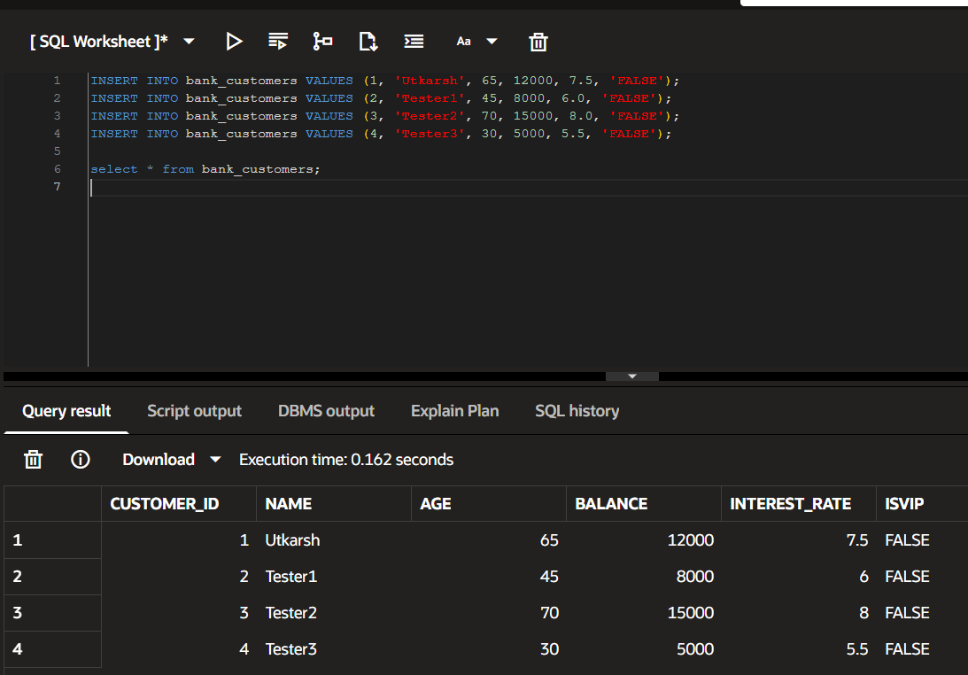

BEGIN
FOR cust IN (SELECT customer_id, age FROM bank_customers)
LOOP
IF cust.age > 60 THEN
UPDATE bank_customers
SET interest_rate = interest_rate - 1
WHERE customer_id = cust.customer_id;
DBMS_OUTPUT.PUT_LINE('Discount applied for Customer ID: ' || cust.customer_id);
END IF;
END LOOP;
COMMIT;
END;
/
OUTPUT:
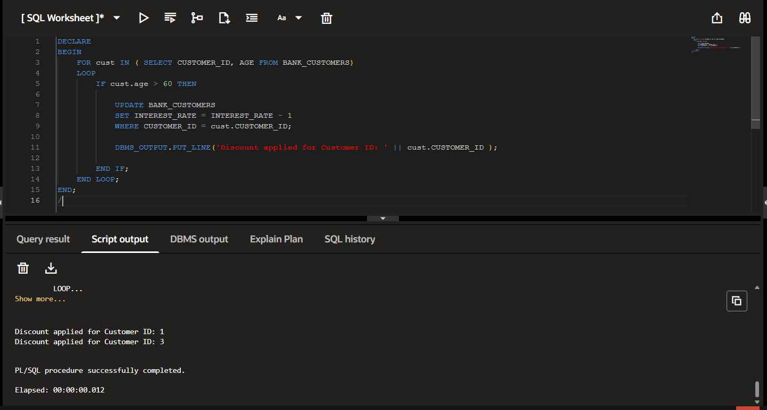

select * from bank_customers;
OUTPUT FOR SCENARIO 1
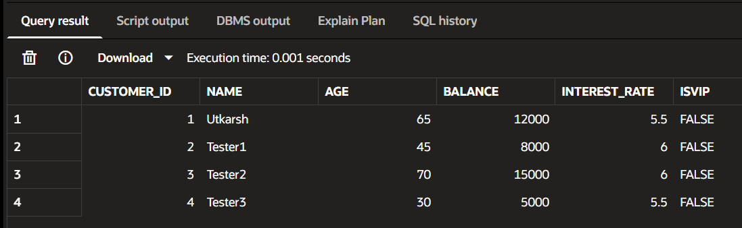

Scenario 2: Promote Customers to VIP Status
BEGIN
FOR cust IN (SELECT customer_id, balance FROM bank_customers)
LOOP
IF cust.balance > 10000 THEN
UPDATE bank_customers
SET isVIP = 'TRUE'
WHERE customer_id = cust.customer_id;
DBMS_OUTPUT.PUT_LINE('VIP status updated for Customer ID: ' || cust.customer_id);
END IF;
END LOOP;

COMMIT;
END;
/

OUTPUT:
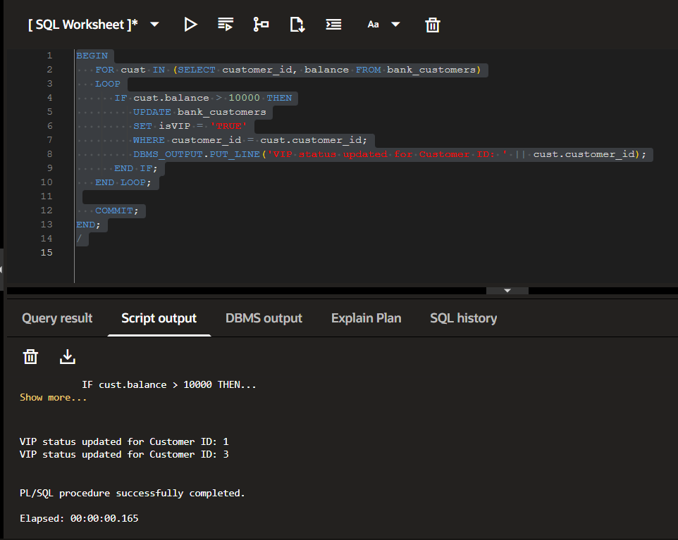

select * from bank_customers;
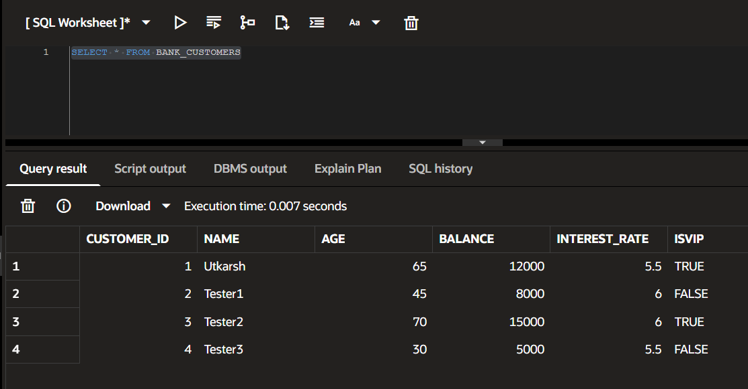

Scenario 3: Send Reminders for Loans Due Within 30 Days
CREATE TABLE loans (
loan_id NUMBER PRIMARY KEY,
customer_id NUMBER,
due_date DATE
);
INSERT INTO loans VALUES (101, 1, SYSDATE + 10);
INSERT INTO loans VALUES (102, 2, SYSDATE + 40);
INSERT INTO loans VALUES (103, 3, SYSDATE + 20);
INSERT INTO loans VALUES (104, 4, SYSDATE + 5);
COMMIT;

SELECT * FROM loans;
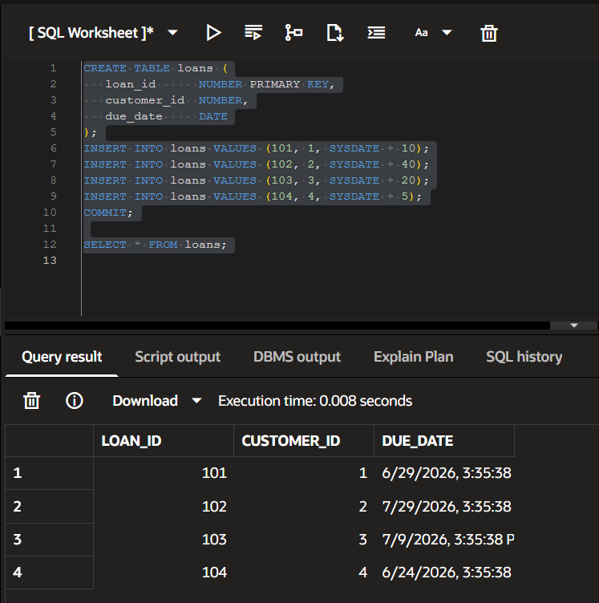
BEGIN
FOR loan_rec IN (
SELECT l.loan_id,
l.customer_id,
l.due_date,
c.name
FROM loans l
JOIN bank_customers c
ON l.customer_id = c.customer_id
)
LOOP
IF loan_rec.due_date <= SYSDATE + 30 THEN
DBMS_OUTPUT.PUT_LINE(
'Reminder: Loan ID ' || loan_rec.loan_id ||
' | Customer: ' || loan_rec.name ||
' | Due Date: ' || TO_CHAR(loan_rec.due_date, 'DD-MON-YYYY')
);
END IF;
END LOOP;
END;
/
OUTPUT:
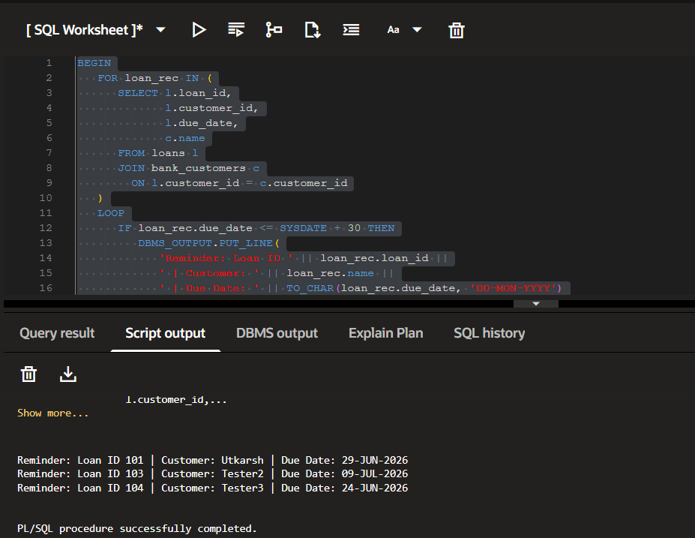

SELECT
c.customer_id,
c.name,
c.age,
c.balance,
c.interest_rate,
c.isVIP,
l.due_date
FROM
bank_customers c
JOIN
loans l
ON
c.customer_id = l.customer_id
WHERE
l.due_date <= SYSDATE + 30
ORDER BY
c.customer_id;

FINAL TABLE OUTPUT FOR SCENARIO 3
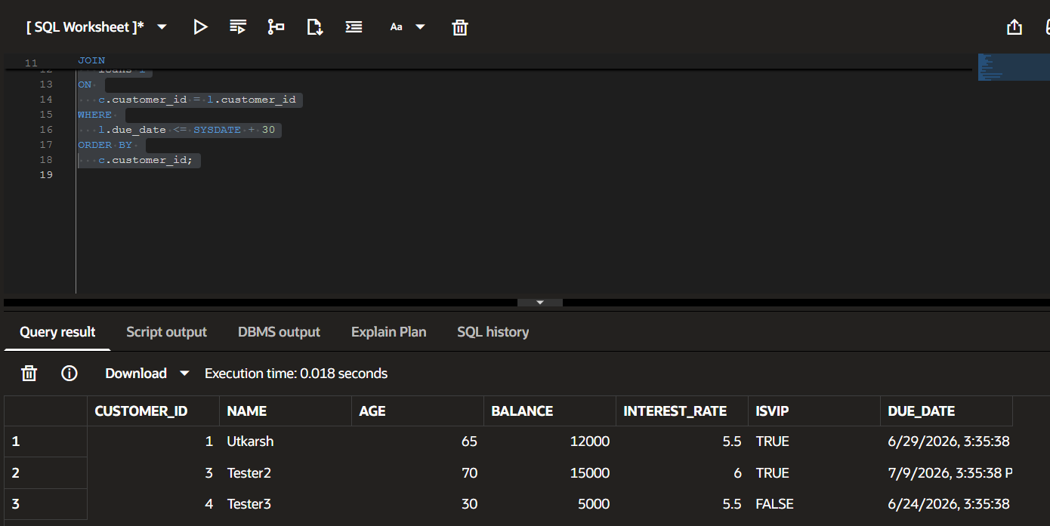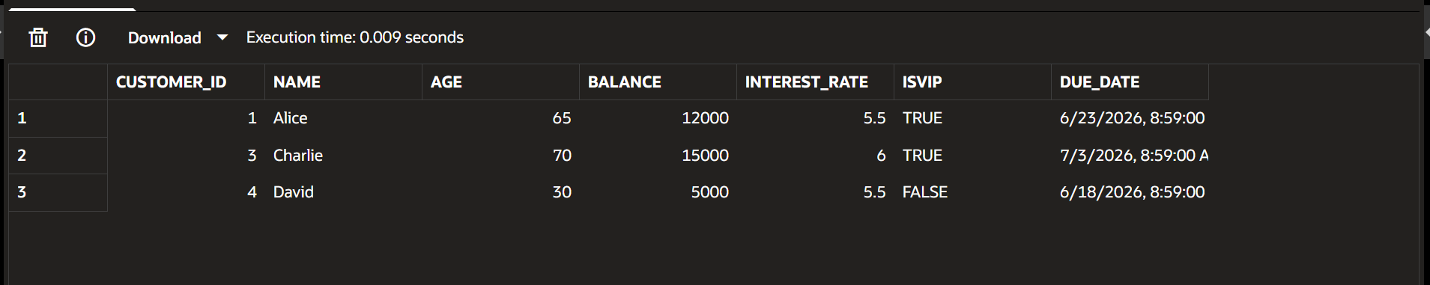

EXERCISE 3-STORED PROCEDURES
SCENARIO 1
CREATE TABLE savings_accounts (
account_id NUMBER PRIMARY KEY,
customer_id NUMBER,
balance NUMBER
);
INSERT INTO savings_accounts VALUES (101, 1, 10000);
INSERT INTO savings_accounts VALUES (102, 2, 20000);
INSERT INTO savings_accounts VALUES (103, 3, 15000);
INSERT INTO savings_accounts VALUES (104, 4, 5000);
COMMIT;

select * from savings_accounts;
INITIAL TABLE
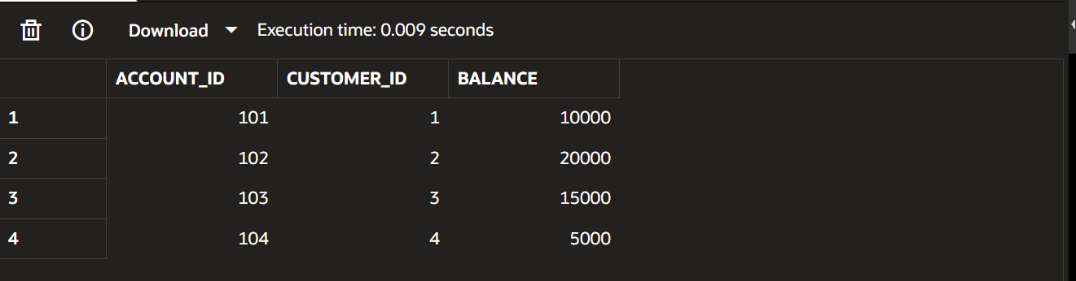

CREATE OR REPLACE PROCEDURE ProcessMonthlyInterest
AS
BEGIN
FOR acc IN (SELECT account_id, balance FROM savings_accounts)
LOOP
UPDATE savings_accounts
SET balance = balance + (balance * 0.01)
WHERE account_id = acc.account_id;

DBMS_OUTPUT.PUT_LINE(
'Interest applied for Account ID: ' || acc.account_id
);
END LOOP;

COMMIT;
END;
/

OUTPUT FOR SCENARIO 1

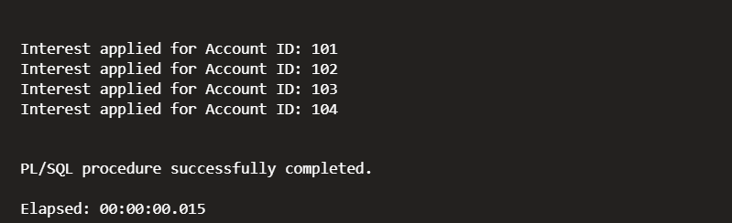
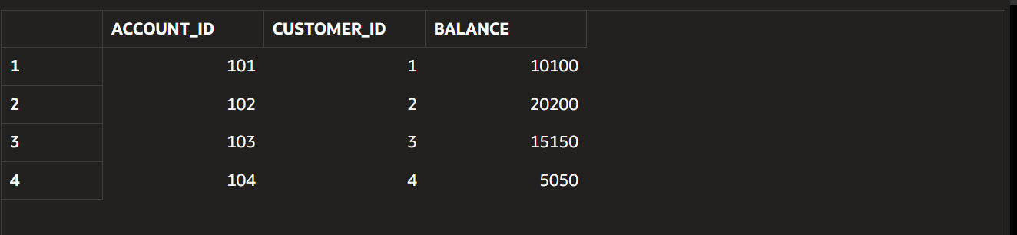
SCENARIO 2
CREATE TABLE employees (
emp_id NUMBER PRIMARY KEY,
emp_name VARCHAR2(50),
department VARCHAR2(30),
salary NUMBER
);
INSERT INTO employees VALUES (1, 'Alice', 'IT', 50000);
INSERT INTO employees VALUES (2, 'Bob', 'IT', 60000);
INSERT INTO employees VALUES (3, 'Charlie', 'HR', 45000);
INSERT INTO employees VALUES (4, 'David', 'HR', 55000);
INSERT INTO employees VALUES (5, 'Eve', 'Finance', 70000);
COMMIT;

CREATE OR REPLACE PROCEDURE ProcessMonthlyInterest
AS
BEGIN
FOR acc IN (SELECT account_id, balance FROM savings_accounts)
LOOP
UPDATE savings_accounts
SET balance = balance + (balance * 0.01)
WHERE account_id = acc.account_id;

DBMS_OUTPUT.PUT_LINE(
'Interest applied for Account ID: ' || acc.account_id
);
END LOOP;

COMMIT;
END;
/
select * from employees;
INITIAL TABLE
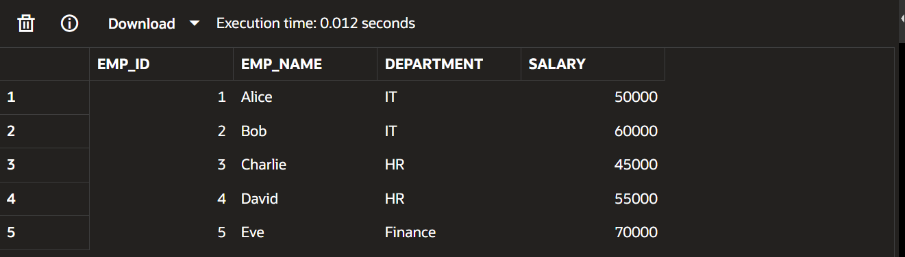

CREATE OR REPLACE PROCEDURE UpdateEmployeeBonus (
p_department IN VARCHAR2,
p_bonus_pct IN NUMBER
)
AS
BEGIN
UPDATE employees
SET salary = salary + (salary * p_bonus_pct / 100)
WHERE department = p_department;

DBMS_OUTPUT.PUT_LINE(
'Bonus of ' || p_bonus_pct || '% applied to department: ' || p_department
);

COMMIT;
END;
/

SELECT * FROM employees;
OUTPUT FOR SCENARIO 2
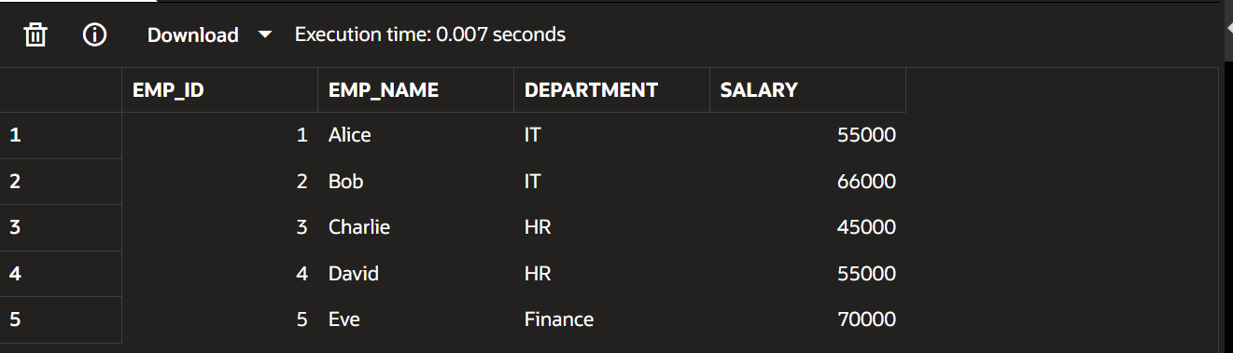

SCENARIO 3
CREATE TABLE accounts (
account_id NUMBER PRIMARY KEY,
customer_id NUMBER,
balance NUMBER
);
INSERT INTO accounts VALUES (101, 1, 10000);
INSERT INTO accounts VALUES (102, 2, 5000);
INSERT INTO accounts VALUES (103, 3, 8000);
INSERT INTO accounts VALUES (104, 4, 2000);
COMMIT;

SELECT * FROM accounts;
INITIAL TABLE
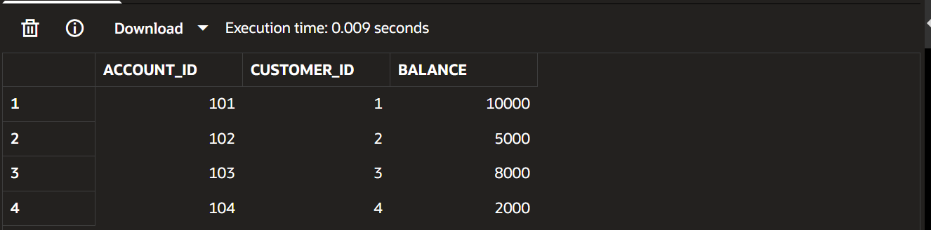

CREATE OR REPLACE PROCEDURE TransferFunds (
p_from_acc IN NUMBER,
p_to_acc IN NUMBER,
p_amount IN NUMBER
)
AS
v_balance NUMBER;
BEGIN

SELECT balance
INTO v_balance
FROM accounts
WHERE account_id = p_from_acc;

IF v_balance >= p_amount THEN

UPDATE accounts
SET balance = balance - p_amount
WHERE account_id = p_from_acc;

UPDATE accounts
SET balance = balance + p_amount
WHERE account_id = p_to_acc;

DBMS_OUTPUT.PUT_LINE('Transfer Successful: ' || p_amount || ' transferred.');

ELSE
DBMS_OUTPUT.PUT_LINE('Transfer Failed: Insufficient Balance.');
END IF;

COMMIT;
END;
/
OUTPUT FOR SCENARIO 3(Transfer 2000 from account 101 → 102)

